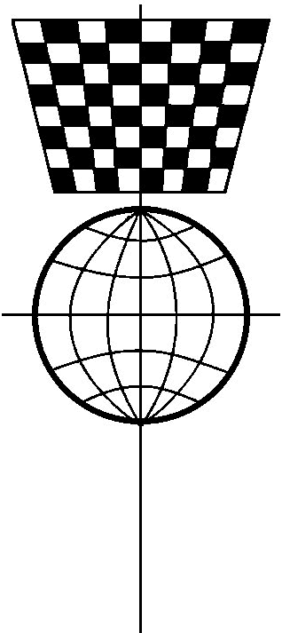
Scottish Correspondence Chess Association

100 Club

The Aim of the 100 Club
The Scottish Correspondence Chess Association 100 club was formed many years ago to provide a valuable source of funding to help meet the running costs of the Association. Each month approximately 50% of all money received is distributed as prizes. There are two monthly prizes and the names of the winners appear in our magazine and on our website. Please give us your support!

How to Join
The club is open to all person aged over 16 years. Units cost £1 monthly and are normally purchased for a period of one year. There is no restriction on the number of units that can be held. For example a subscriber may purchase two units at an annual cost of £2 x 12 = £24. For administrative purposes it is extremely helpful if the method of payment is by Standing Order. For convenience, an authorisation form is attached. However, cheques are of course acceptable.

Instructions  All applicants should complete the application form below.  If you are paying by cheque, return your completed application form along with your cheque to: Ian Whittaker, SCCA Treasurer, Inchkeith House, Lauder, Berwickshire TD2 6TE. Please make the cheque payable to the Scottish Correspondence Chess Association.  If you wish to pay by standing order, return your completed application form to George Livie, and send your completed Standing Order Authority directly to your bank. | 

Application Form

Name(s)

Address
 |  | Postcode
Number of Units |  | Number of Months
Total Due | £ | Paying by S.O. | yes/no
I/we apply for membership of the Scottish Correspondence Chess Association 100 Club and agree to abide by SCCA rules. I/we are over 16 years old.
Signature(s)

Standing Order Authority |  |  | To the Manager:

Your Bank’s Name
Your Bank’s Address
 |  | Postcode
Your Account Name
Your Account Number
Amount You Wish to Pay Each Month |  | £ | (units x £1)
Payment Start Date | (day) | (month) | (year)
Please commence the above payment on the start date and continue monthly thereafter until further notice from me/us in writing.
Credit Account | Scottish Correspondence Chess Association
Bank | Bank of Scotland, 10-16 King Edward Street, Perth PH1 5UT
Sort Code | 80-91-28 | Account Number | 00248355

Signature(s)

